**Final Project**

**Lego Set Tracker**

**By**

**Kevin M. Albright**

**Project Overview:**

This application will allow users to keep track of their Lego sets.

1. The user will be able to view the sets that have been entered and saved.
2. The user will be able to add, edit and delete items from the list.
   1. The user will be able to add new sets to the list.
      1. When adding a set, the user will be able to enter the ID number, the name of the set, the theme that the set comes under, how many of the set they have, the number of pieces in the set, the date first set of this type is acquired.
      2. Date will default to current day’s date.
      3. The user will be able to add a new theme if the theme is not already in the list.
         1. The user will not be able to add duplicate theme names.
   2. The user will be able to delete a set from the list.
      1. The user will be asked to confirm their choice before deletion.
   3. The user will be able to correct/fix quantities and misspellings of an item.
   4. The user will receive confirmation of their actions: add to, delete, or update info.
   5. The user will not be able to enter duplicate sets.
3. The user will be able to view number of unique set, total quantity of sets, and total number of pieces.

**Software and Hardware requirements:**

Compiled SDK Version: 23

Build Tools Version: 23.0.2

Target SDK: 23

Minimum SDK: 14

|  |  |
| --- | --- |
| **Dependencies:** |  |
| com.android.support: |  |
|  | appcompat -v7:23.1.1 |
|  | design:23.1.1 |

|  |  |  |  |
| --- | --- | --- | --- |
| **Emulated Tests on:** | **API:** | **Target:** | **CPU/ABI:** |
| Nexus 10 | 23 | Google APIs | x86_64 |
| Nexus 10 | 21 | Google APIs | x86_64 |
| Nexus 5 | 23 | Google APIs | x86_64 |
| Nexus 5 | 17 | Android 4.2.2 | x86 |
| **Real World Test on:** |  |  |  |
| Samsung Note Pro | 21 | Android 5.0.2 |  |
| Samsung Note 4 | 21 | Android 5.1.1 |  |
| Motorola Droid Bionic | 16 | Android 4.1.1 |  |

Programed Using Mostly Android Studio 1.5.0 started on 1.4.1

Using Gradle 2.8

Program uses Android’s default version of SQLite

Used/Created on a Windows 7 64bit machine.

**Project Description:**

**Common Menu Items:**

* Press Overflow icon to display menu items
  + Press “Sets” to display Lego Sets List Activity
  + Press “Themes” to display Lego Themes List Activity
  + Press “Reports” to display Lego Report Dialog
    - Press “OKAY” button to dismiss Report Dialog
    - Touch outside dialog to dismiss Report Dialog

**Lego Sets List:**

* Display List of Lego Sets
* Press Plus sign icon to display a blank Lego Set Detail View
* Press a Lego Set to display selected Lego Set Details
* Long press to display Delete Lego Set Dialog
  + Press “Delete” button to Delete Selected Lego Set
  + Press “Cancel” button to cancel Delete Lego Set Dialog
  + Touch outside dialog to cancel Delete Lego Set Dialog

**Lego Set Details:**

* Input Lego Set ID
* Input Lego Set Name
* Press Theme button to display Themes Picker Dialog
  + Press “Add Theme” button to display Add New Theme Dialog
    - Press “Save” button to Save Lego Theme
      * If input is invalid will display error message under text field.
      * If valid will save theme to database, close Add New Theme Dialog, and place new theme as the text of the Lego Set Details Theme button
    - Press “Cancel” button to cancel Add New Theme Dialog, and then re-opens Themes Picker Dialog
    - Touch outside dialog to cancel Add New Theme Dialog
  + Press “Cancel” button to cancel Themes Picker Dialog
  + Touch outside dialog to cancel Themes Picker Dialog
* Press Calendar Button to Display Calendar Dialog
  + Press “Ok” button to save Calendar date
  + Press “Cancel” button to cancel Calendar Dialog
  + Touch outside dialog to cancel Calendar Dialog
* Input Lego Set number of Pieces
* Input Lego Set Quantity
* Press “Cancel” button to close Detail view and discard input.
* Press “Save” button to save input to database
  + If input is invalid error hints will appear under appropriate input fields or as an icon beside Theme and Calendar buttons
  + When valid will save to database, close the Detail view, and update the Lego Set List

**Lego Themes List:**

* Display List of Lego Themes
* Press Plus sign icon to display a blank Lego Theme Detail View
* Press a Lego theme to display selected Lego set details
* Long press to:
  + Display delete Lego set Dialog – If Theme is not in use
    - Press “Delete” button to delete selected Lego set
    - Press Cancel” button to cancel Delete Lego Theme Dialog
    - Touch outside dialog to cancel Delete Lego Theme Dialog
  + Display Information Dialog – If Theme is in use
    - Press “Okay” button to dismiss Information Dialog
    - Touch outside dialog to dismiss Information Dialog

**Lego Theme Detail:**

* Input Lego Theme Name
* Press “Cancel” button to close Detail view and discard input
* Press “Save” button to save input to the database
  + If input is invalid error hints will appear under the input field
  + When valid will save to database, close Detail view, and update the Lego Theme List

**Image file name:** Files - all Diagram.jpg

Trying to show how the Java and XML files relate to one another. Diagrams out how the activities work in relation to what is opened, used, and inflated.

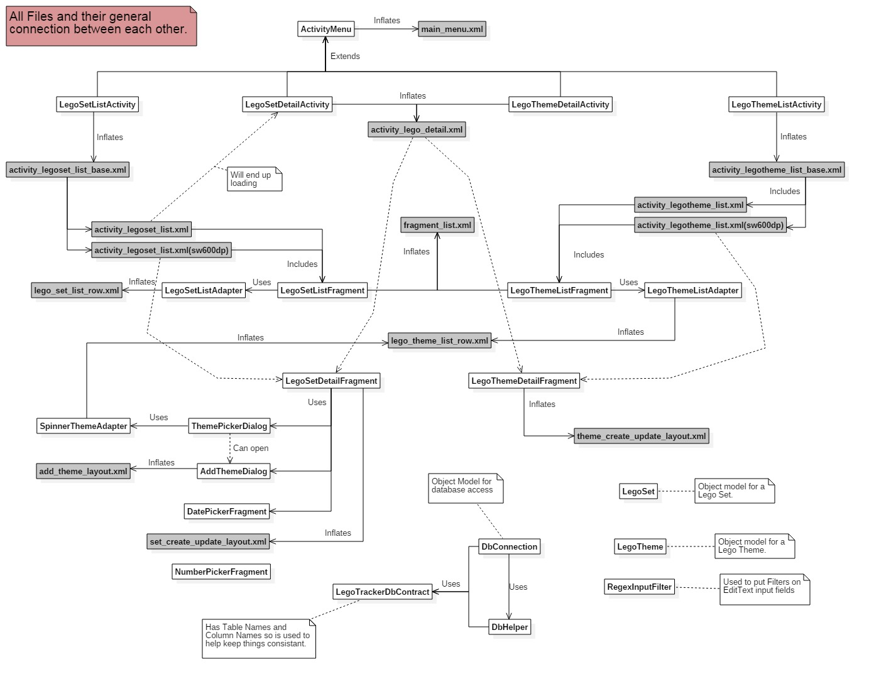

**Image file name:** Files - LegoSet Phone size Diagram.jpg

Diagrams out how the LegoSetListActivity works in relation to what is opened, used, and inflated when used on a phone size screen.

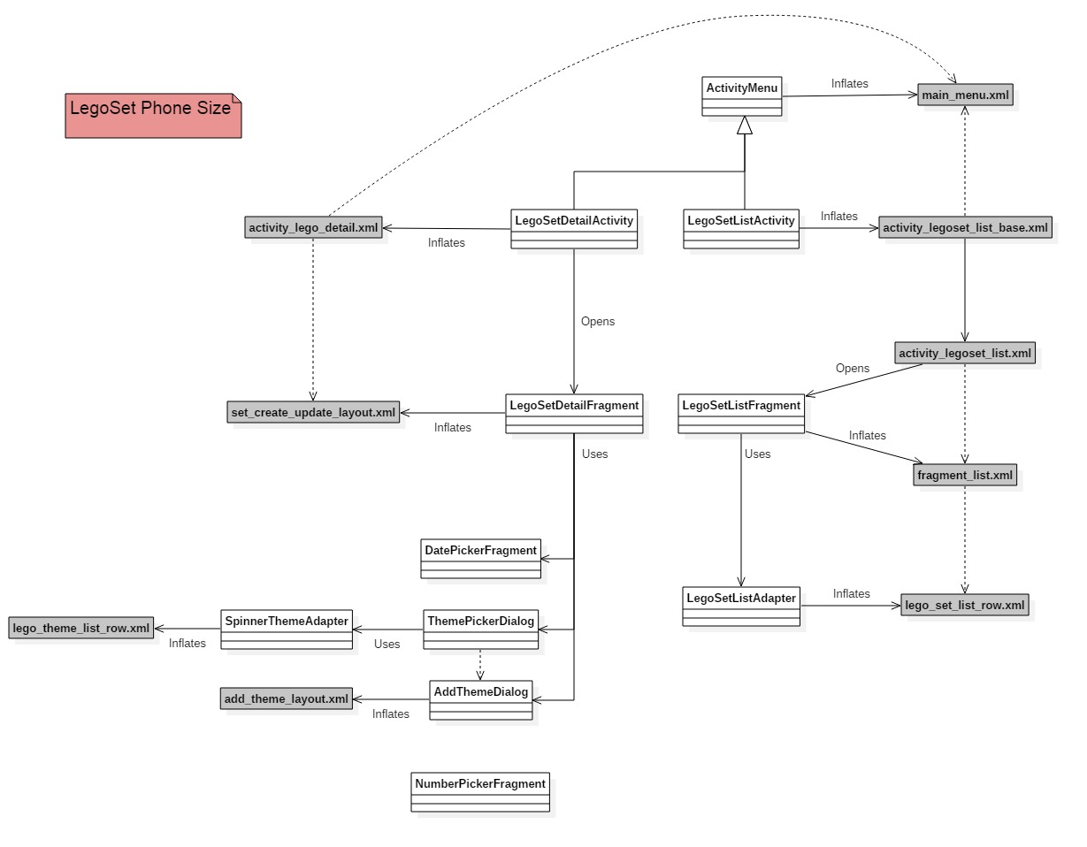

**Image file name:** Files - LegoSet Tablet size Diagram.jpg

Diagrams out how the LegoSetListActivity work in relation to what is opened, used, and inflated when used on a tablet size screen.

